Industrial Portrait of Guangdong Integrated Circuit Industry
(Aligned with the Three Major Industrial Layouts for High-Quality Development in Guangdong, 2026)

I. Overall Industrial Positioning
The integrated circuit industry in Guangdong Province is the core pillar of the province’s strategic emerging industries and the main front of the “Chip Strengthening Project”. It is deeply integrated with the three major directions: the upgrading of traditional industries, the expansion of emerging industries, and the layout of future industries. As a key “bottleneck” industry supporting the high-quality development of the digital economy and manufacturing sector, it relies on the Pearl River Delta, the world’s largest electronic information manufacturing base, and holds 60% of the national chip application market. The province is accelerating the transformation from a “chip buyer” to a “chip seller”, striving to build the “third pole” of China’s integrated circuit industry.

II. Scale Development and Growth in the Past Three Years: Leading in Volume and Growth Rate
- Total Industrial Scale: The total output value of the entire industrial chain reached 360.4 billion yuan in 2024, a year-on-year increase of 22%, ranking firmly among the national first echelons. It is expected to exceed 450–500 billion yuan by 2026, maintaining rapid expansion. Driven by sustained high growth in recent years, the scale is expected to approach 600 billion yuan by 2030.
- Growth Momentum: Output growth rates from 2023 to 2025 were 5.2% → 18.3% → 21.0%. By 2025, the industrial growth rate reached as high as 21%, significantly higher than the national average of 11.2%. It has led the country in growth rate for three consecutive years, demonstrating outstanding counter-cyclical resilience and growth momentum.
- Capacity Expansion: The monthly production capacity of 12-inch wafers is expected to reach 250,000–300,000 pieces by 2026. The output value of the wafer manufacturing sector grew by 102%, becoming the fastest-growing segment of the entire industrial chain.
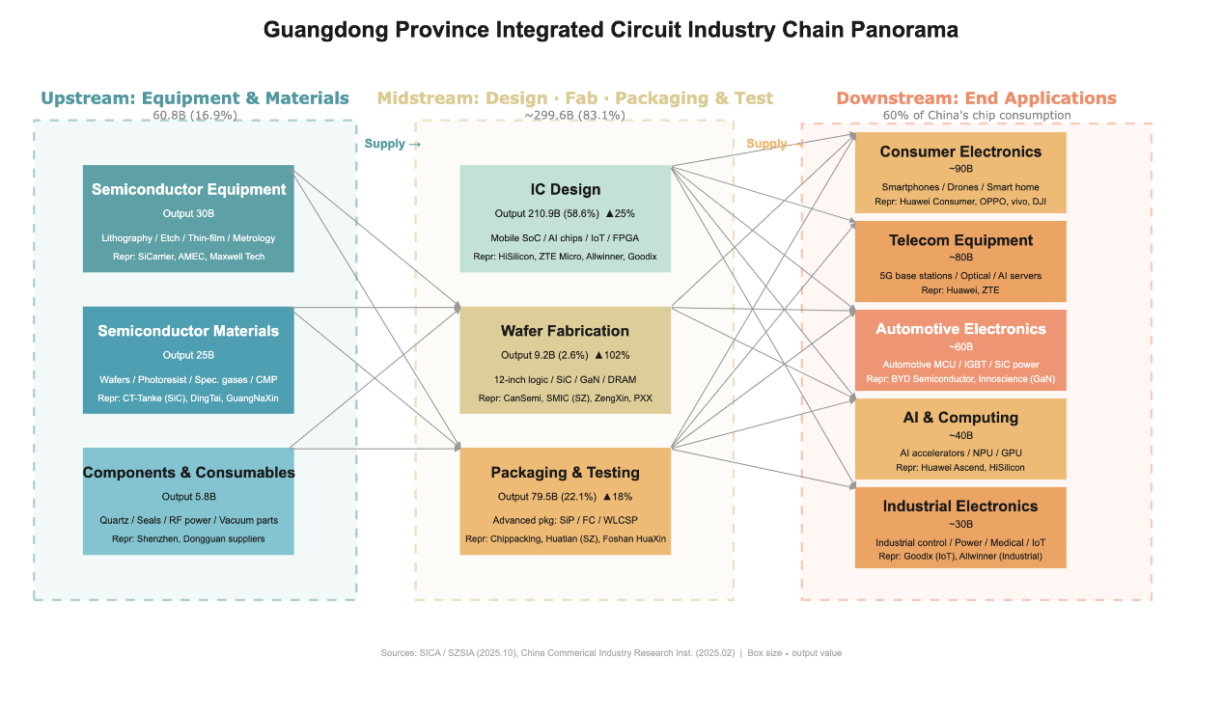

III. Industrial Chain Structure: Dominated by Design, Strong Midstream, Weak Upstream
- Behind the impressive scale and growth rate, Guangdong’s integrated circuit industry has not achieved balanced development across all segments, but presents a distinct unbalanced structure of “strong midstream, weak upstream, and dominant design”. This pattern is both a concentrated reflection of Guangdong’s industrial advantages and a key direction for subsequent industrial upgrading.
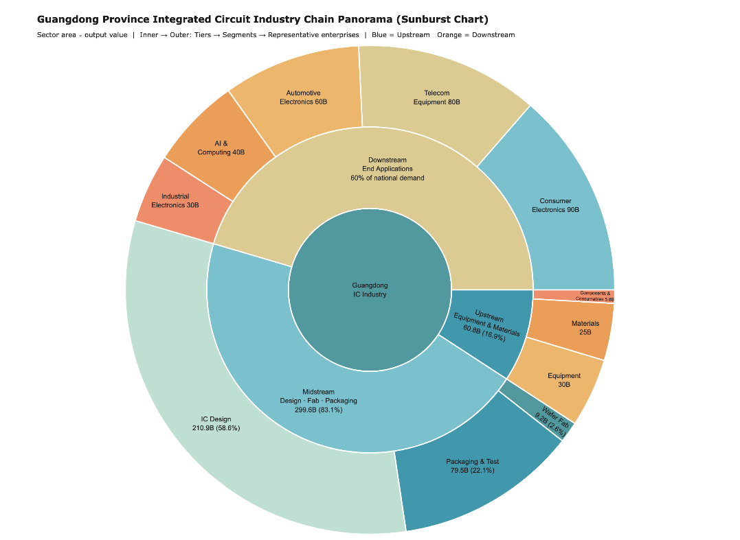

- Core Advantage Segment: IC design achieved an output value of 210.9 billion yuan, accounting for 58.6%, ranking first in China. Nanshan District of Shenzhen is a national hub for IC design, serving as the primary growth pole of the industry.
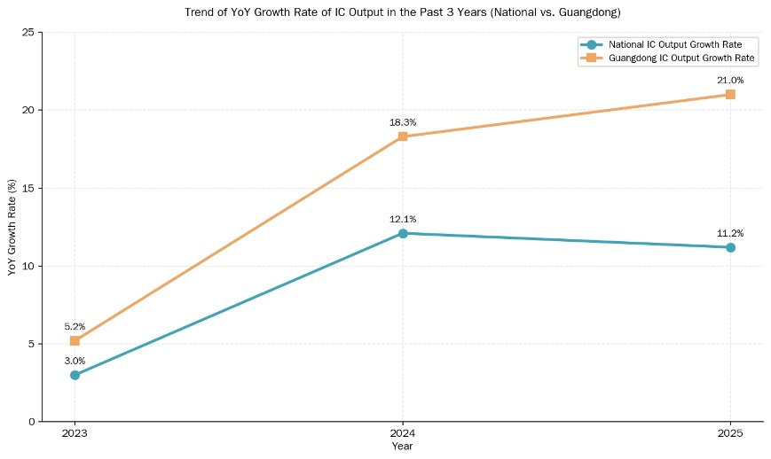
- Stable Supporting Segment: Packaging and testing achieved an output value of 79.5 billion yuan, accounting for 22.1%. Mature packaging and testing clusters have been formed in Foshan and Zhongshan, with complete supporting capabilities.
- Rapidly Catching-up Segment: Wafer manufacturing achieved an output value of 9.2 billion yuan, accounting for only 2.6%. Despite a small base, it has seen explosive growth, with projects such as Yuexin Semiconductor and SMIC Shenzhen ramping up production rapidly.
- Obvious Weakness Segment: Equipment and materials achieved an output value of 60.8 billion yuan, accounting for 16.9%. Domestic substitution is still in an accelerated stage, representing the weakest part of the entire chain.
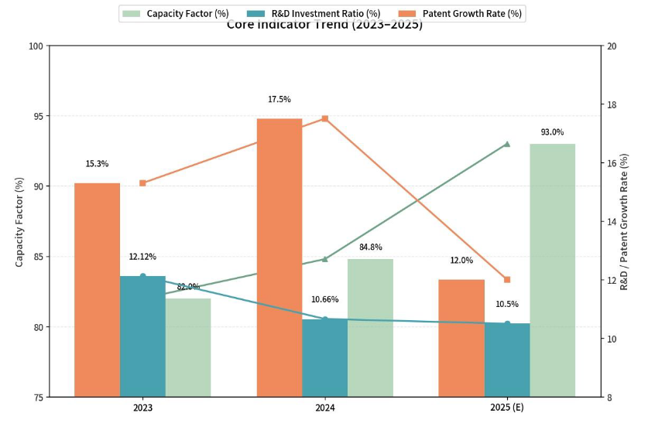

IV. Innovation Capability: High Input, High Conversion, High Efficiency 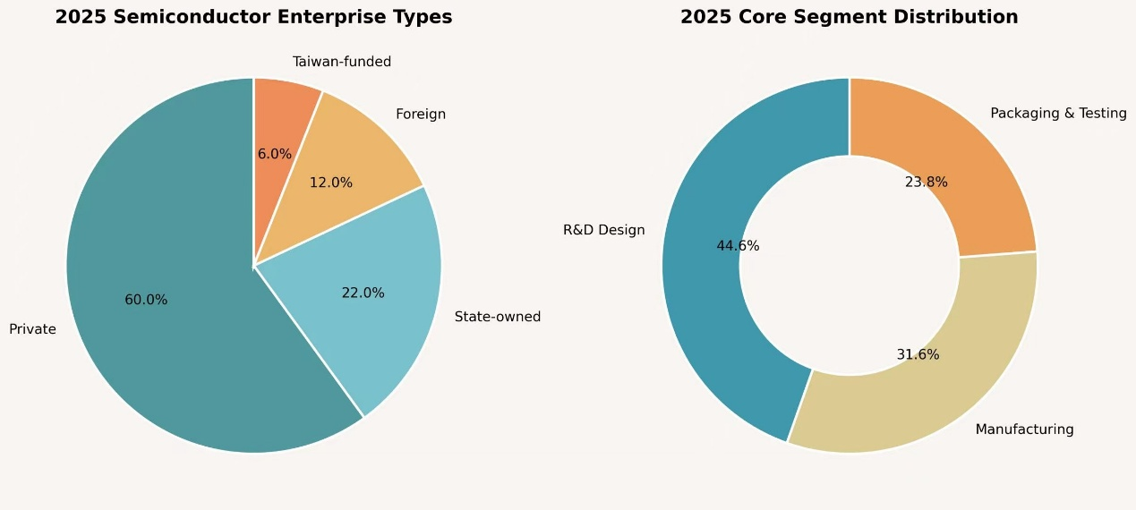
- R&D Investment: The industry’s R&D investment ratio has remained at 10.5%–12.12% all year round, a relatively high level in the global semiconductor industry, laying a solid foundation for innovation.
- Output Efficiency: The growth rate of semiconductor patents in the Greater Bay Area has consistently outpaced the national average, with the proportion of invention patents rising to 35.3%. The capacity utilization rate of core manufacturing enterprises increased from 82% to 93%, with a production-sales ratio of 100%, forming a positive cycle of “high R&D investment → high-quality patents → high capacity utilization”.
- Technological Maturity: 85% for the design sector (top-tier in China), 75% for manufacturing and packaging/testing (steady breakthroughs), and only 60% for materials and equipment (prominent weaknesses in underlying technologies).

- V. Market Demand: Fully Covering and Supporting the Three Major Industrial Layouts
The downstream applications are highly compatible with the province’s three major industries (traditional, emerging, future), featuring a diversified and stable demand structure:
- Empowering Traditional Industries: Consumer electronics account for 35%, providing core support for the transformation and upgrading of home appliances and consumer electronics.
- Strengthening Emerging Industries: Communications equipment + automotive electronics account for a combined 43%, undertaking the main demand from 5G, new energy vehicles and other emerging industries
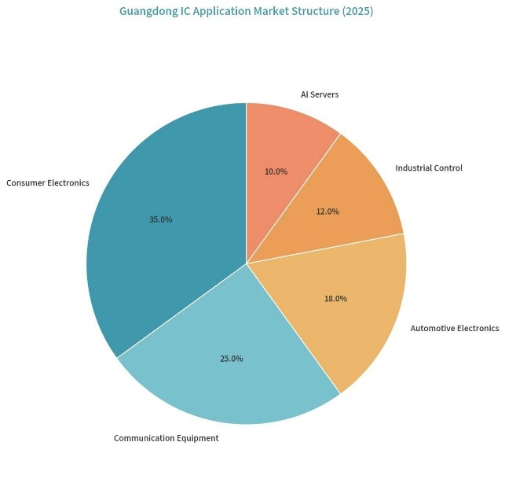
- Layout Future Industries: Industrial control, AI servers, advanced computing and other fields account for 22%, seizing the commanding heights of technologies and markets for future industries.

VI. Market Entities: Led by Private Enterprises, Based Ownership Structure: Private enterprises account for 75%–80%, serving as the main force of innovation and market development; state-owned enterprises account for 10%–15%, focusing on heavy-asset manufacturing; foreign-funded/joint ventures account for 5%–10%, supplementing capabilities in high-end manufacturing and packaging/testing.

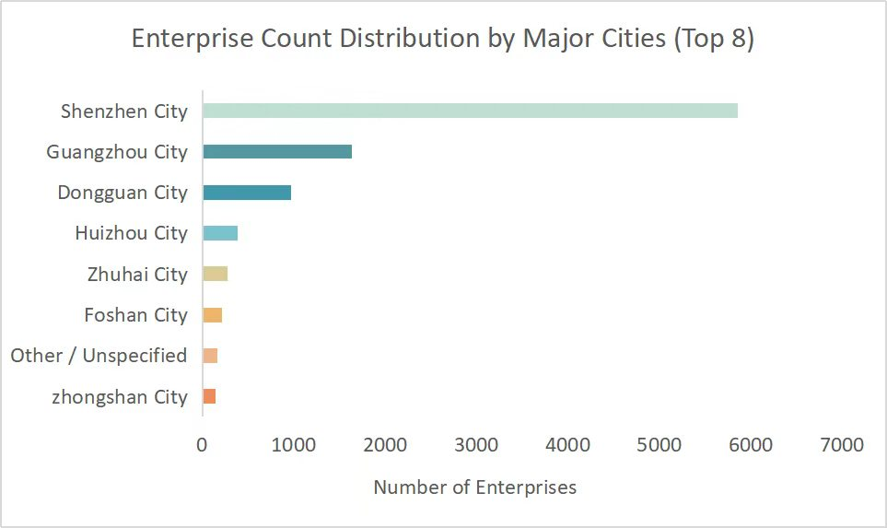
Scale Structure: Small and medium-sized enterprises (SMEs) account for 90.3%, forming a solid foundation for the industrial ecosystem; above-scale enterprises account for 5.86%, and leading enterprises account for only 3.84%, lacking strong leadership and driving forces.
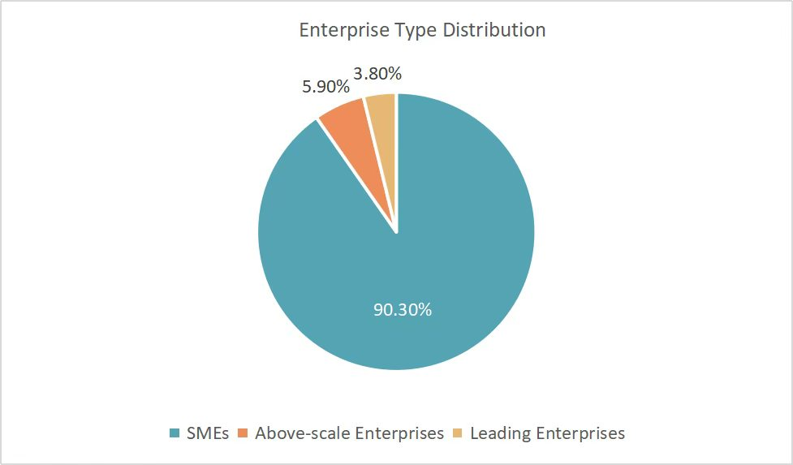
This pie chart shows the scale structure of integrated circuit enterprises in Guangdong Province: SMEs account for as high as 90.3%, above-scale enterprises account for 5.9%, and leading enterprises account for only 3.8%. The industry presents a pyramid structure of “SMEs as the foundation, above-scale enterprises as the backbone, and a small number of leading enterprises”. It indicates a solid industrial ecosystem with sufficient innovation vitality, but insufficient industry leadership, featuring the overall characteristics of “large but not strong, scattered but not concentrated”.
- Market Concentration: CR5 is 52.56% and CR10 is 67.15%. The industry concentration is relatively low, showing the characteristics of “large but not strong, scattered but not concentrated”, with broad room for integration and upgrading.
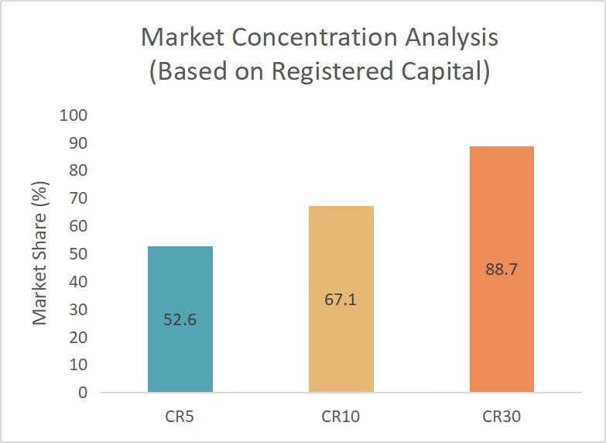
Note: This market concentration CR index is calculated based on registered capital of enterprises, not operating revenue/market share, and only reflects the capital concentration characteristics of the industry.

VII. Spatial Layout: Highly Concentrated in the Pearl River Delta, Forming a “3+N” Pattern
The industry is highly concentrated in the Pearl River Delta, forming a “3+N” layout of “Shenzhen as the core, Guangzhou and Zhuhai as coordination, and the Pearl River Delta as linkage”:
- Shenzhen: Absolute core, accounting for 79% of the province’s revenue, with 727 enterprises, covering the entire industrial chain, and possessing top-tier design and innovation capabilities nationwide.
- Guangzhou: Manufacturing core, led by Yuexin Semiconductor, building a 12-inch wafer manufacturing base.
- Zhuhai: Prominent features in IC design and compound semiconductors, serving as the second pole of IC design in the Pearl River Delta.

- Nine cities in the Pearl River Delta: Enterprises account for 95.64% of the province’s total, and capital accounts for 99.80%, showing significant industrial agglomeration effects.

VIII. Core Advantages and Key Weaknesses

Core Advantages
- Leading in both scale and growth rate, with a solid benchmark status in emerging industries;
- Top-tier IC design capabilities nationwide, high innovation input and conversion efficiency, intensive policy and capital support;
- Holding the largest application market in China, with a complete closed loop of demand and industry;
- Strong vitality of private enterprises, solid SME ecosystem, and strong policy support.

Key Weaknesses
- Weak upstream industrial chain (equipment, materials), constrained by underlying technologies;
- Small scale of wafer manufacturing, unbalanced chain structure;
- Insufficient number of leading enterprises, low industry concentration;
- Persistent bottlenecks in high-end talents and advanced processes. 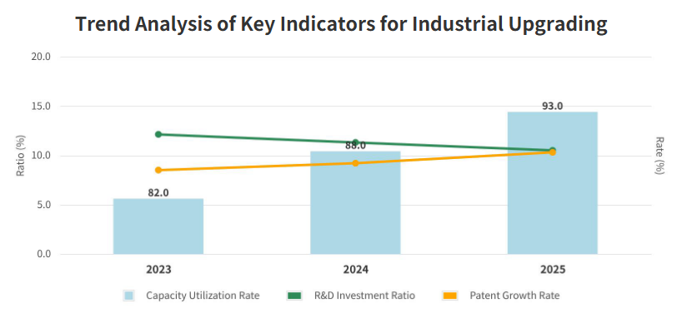

IX. Summary of Industrial Portrait
The integrated circuit industry in Guangdong boasts large scale, rapid growth, strong design capabilities, and robust market demand, perfectly matching the province’s high-quality development direction of transforming and upgrading traditional industries, expanding emerging industrial clusters, and planning ahead for future industries. Meanwhile, it faces four core problems: weak upstream sectors, insufficient manufacturing scale, shortage of leading enterprises, and scattered industrial layout.
In the future, it is necessary to focus on strengthening and supplementing the industrial chain, prioritize upgrading weaknesses in materials, equipment and wafer manufacturing, foster leading enterprises, optimize regional coordination, and build a world-class integrated circuit industrial cluster featured by leading design, breakthrough manufacturing, complete supporting facilities, and efficient innovation, providing core chip support for the high-quality development of Guangdong’s manufacturing industry.

